INT 133B: What’s Wrong with the World?
How Might We Fix It?
Perspectives and Solutions from the Environmental Humanities and Social Sciences
Summer Session B 2019
Mondays, Tuesdays, Wednesdays, Thursdays: 12:30-3:20 p.m.
Phelps 1160
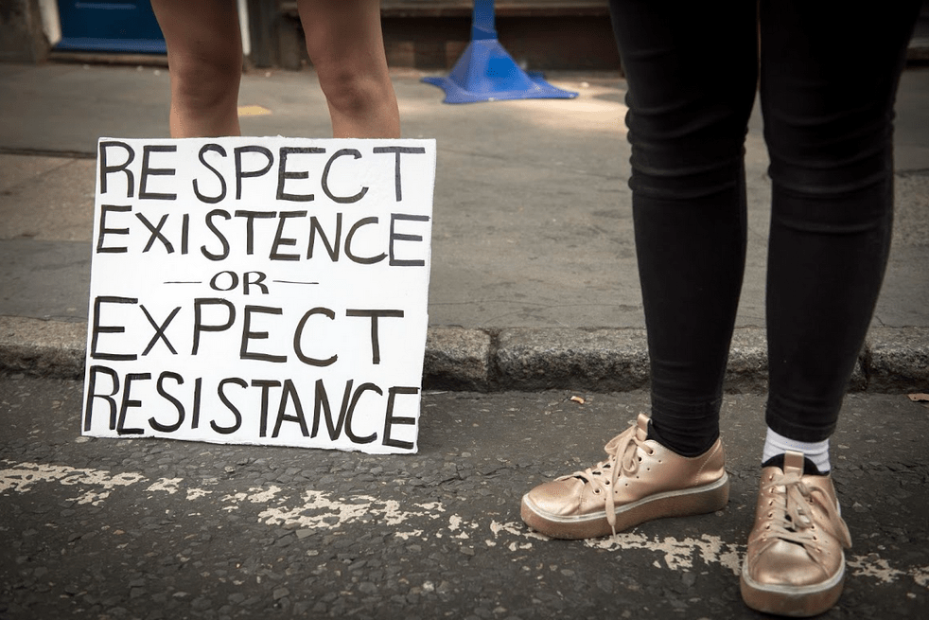

John Foran, Instructor, Professor of Sociology
Office: 3417 Social Sciences Building
E-mail: foran@soc.ucsb.edu
Office Hours: John’s office hours will be held after class at the Coral Tree Cafe (near Cheadle Hall) on Mondays from 3:30 to 4:30 p.m. and at the Library Cafe on Tuesdays from 3:30 to 4:30 p.m., and by appointment (I’ll also do lots of e-mail consultation)
Joslyn Fritz, Teaching Assistant
E-mail: fritz@bren.ucsb.edu
Office hours: Mondays, 11:15 a.m to12:15 p.m. and Tuesdays, 3:20 to 4:20 p.m. both at the Coral Tree Café
Feel free to discuss your work with John or Joslyn at class, by e-mail, or in office hours.
*

If you care about children, health, poverty, farmers, food, hunger, or the economy, you really have no choice but to care about climate change. The reasons for acting may be somber, but the fight is a gift and an honor. What it will give you in return is meaning, purpose, hope, your best self, some really good company, and the satisfaction of being part of victories also to come. But what victory means needs to be imagined on a whole new scale as the news worsens….
This is, among other things, a war of the imagination: the carbon profiteers and their politicians are hoping you don’t connect the dots, or imagine the various futures we could make or they could destroy, or grasp the remarkably beautiful and complex ways the natural world has worked to our benefit and is now being sabotaged, or discover your conscience and voice, or ever picture how different it could all be, how different it will need to be.
They are already at war against the wellbeing of our Earth. Their greed has no limits, their imagination nothing but limits. Fight back. You have the power. It’s one of your gifts.
Rebecca Solnit, “2013 as Year Zero for Us – and Our Planet“
*
This 8-unit course will be team taught by Ken Hiltner, Professor of English and Director of the Environmental Humanities Center, and John Foran, Professor of Sociology and co-founder of the UCSB Environmental and Climate Justice Hub. What you are reading right now is John Foran’s half of the course, which will be taught on Mondays and Tuesdays.
In this course, we will investigate the future, asking what might the world look like in the year 2030? 2040? 2050? Or how about 2020?? What will be the state of climate change? What will schools, cities, agriculture, jobs, nations, energy sources, technology, political systems, international relations, the global and local economy, and much more look like? How will people make sense and meaning of their world? What future worlds can we foresee from where we are now, ranging widely and wildly from the awful to the utopian? How will we get to the better worlds we hope to be living in?
Starting with the current political, economic, cultural, and climate crises of Earth and humanity, we consider alternatives to the present system – sustainable ecovillages, buen vivir (roughly, “living in a better way”), Transition Towns, degrowth, the rights of Mother Earth, and ecosocialism/ecofeminism among them – and as we begin to imagine our roles in building what could possibly turn out to be a far better world by 2050, if not much sooner! We will also consider the ways that climate change is being fiercely debated on the public stage through a careful look at the rhetoric of these debates.
This course will involve immersive, project-based work, with role playing, creative productions, individual and/or group projects, and more. This is not a multiple choice, mid-term and final class! Essential to these two courses that are one will be a collaborative model of discovering, curating, and analyzing material.
Statement of Purpose and Course Description – PLEASE READ THIS
Why is this class important? Because it’s your (our) future we’ll be trying to figure out how to fight for!
This special course opens upon the current crisis of the Earth and humanity, marked by economic insecurity, a lack of faith in political parties, pervasive cultures of violence, and now, the wild card that makes them all much scarier – climate crisis.
But this course is really focused on hope, imagination, and the roles all of us could play in building a far better world in our lifetimes.
Visionary climate justice scholar-activist Naomi Klein has said: “There is no more potent weapon in the battle against fossil fuels than the creation of real alternatives.” Sociologist Constance Lever-Tracy adds: “We must ultimately aim for a thorough going de-carbonisation, a halt to all emissions, by a complete revolution in the way we produce and live.”
This means we will need to take action to deal with the most pressing problem of the 21st century, the problem of climate change. Importantly, this means moving the world as rapidly as possible toward the most ambitious possible global climate and sustainable consumption goals, contributing to the strongest possible global social justice movement, and through both of these channels helping to bring about the creation of a low-carbon, peaceful, equitable, and deeply democratic future. A simple working definition of sustainable development might be “a just and ecologically-based society”; the 1987 Brundtland Report – also known as Our Common Future – has given the most famous definition: “Sustainable development is development that meets the needs of the present without compromising the ability of future generations to meet their own needs.”
The main focus of this course is to train our sociological and ecological imaginations to co-create the kind of society that might weather the climate maelstrom that is coming and actually come out on the other side (or more realistically in the midst of it as it inexorably deepens) with societies far more suited to human well-being and thriving than the ones we presently have all around the world.
I believe that if we are to pass on a world worth living in to the next generation (that’s you!), this movement against the crises besetting us and for the collective project of climate justice – in the broadest sense of the term – must become the biggest (and most effective) the world has ever seen.
Background and Meaning of What We Are Going to Do Together
A growing international scientific consensus has emerged that there is now only a 50 percent chance that the official United Nations target of limiting the rise in average temperature to less than 2 degrees Celsius [about 3.8 degrees Fahrenheit] by the year 2050 would effectively avert irreversible climate change (and recent reports indicate that there is just a five percent chance of actually staying below 1.5 degrees).
In 2012, climate activist and scholar Bill McKibben estimated the cap for maximum atmospheric CO₂ [carbon dioxide, which along with methane is the main greenhouse gas responsible for global warming] emissions at 565 gigatons as the upper limit for staying at or below a 2 degrees Celsius temperature rise. With annual global emissions currently running around 30 gigatons a year, this cap was then roughly equal to a nineteen-year supply – till about 2030 – if “business as usual” trends of economic production and growth continued. The terrifying part is that the estimate of the world’s already proven reserves of fossil fuels exceeds McKibben’s cap by five times. In other words, the richest corporations in the history of the world would have to forego four-fifths of their future earnings – by some estimates, an astronomical $20 trillion or more. But instead, they are currently spending over $600 billion a year trying to discover new sources of fossil fuels – fracking, tar sands, deep-water drilling, Arctic oil, mountain-top removal – while each year the amount we can afford to burn decreases. To their great dishonor most of the world’s political leaders are actually subsidizing the extraction of fossil fuels to the tune of another $600 billion annually.
Equally distressing, the 2015 international climate treaty known as the “Paris Agreement” is not nearly adequate for the task, since if every one of its non-binding country pledges are met, we are still headed for around three degrees of warming. The dominant parties to the climate negotiations continue to advance positions completely at odds with climate science, thus ignoring the terrible fact that humanity is on a collision course with nature that we cannot win. The words “fossil fuels” do not even appear in the Agreement.
Unfortunately, meanwhile, the 2015 international climate treaty known as he “Paris Agreement” is not nearly adequate for the task, as the dominant parties to the climate negotiations continue to advance positions completely at odds with climate science, thus ignoring the terrible fact that humanity is on a collision course with nature that we cannot win.
The Intergovernmental Panel on Climate Change, or ICPP, is the world’s most distinguished body of climate scientists and others who are mapping the extent of our climate crisis. Their most recent assessment concluded that our only viable option would require massive (unspecified) social transformation. In the words of activist journalist Dahr Jamail:
A landmark UN report released in October [2018] served as an imminent warning that if governments fail to act swiftly and dramatically (and within the next dozen years), droughts, flooding, and increasingly extreme heat waves will increase drastically.
In the Paris Climate Change Agreement, global governments pledged to try to keep warming within a limit of 1.5°C above pre-industrial levels, in order to prevent increasingly catastrophic impacts.
In the recent UN report, experts stated that without urgent and unprecedented changes, meeting the 1.5°C [the upper limit we can safely allow] would be impossible [italics and brackets added by JF].
The good news is that since at least 2007, a promising global climate justice movement has emerged behind the slogan “System change, not climate change!” and is making demands for a socially just, scientifically informed, and legally binding treaty, sometimes called by activists at the negotiations a FAB (fair, ambitious and binding) treaty. Governments who do not want to vote for it, or whose short-term interests and economic elites are not served by signing, will need to be persuaded or forced to do the right thing by their own citizens and Earth citizens everywhere – that is, by us. One major question addressed in this course has been posed by my friend Bill Barnes: “Can we create new, transformative narratives to inspire political movements able to force vigorous engagement with climate change?”
This emphasis on finding new narratives puts us firmly in the domain of the environmental humanities and qualitative social sciences, the perspectives that inform this course. And it is an invitation to you – to all of us – to put our growing knowledge and imaginations to good purpose!
This course is thus about gaining useful knowledge that will enable positive action to secure a better future. This course is for you, about you, and ultimately will be driven by you.
My Philosophy of Teaching and Learning
Learning and teaching are complex, endlessly fascinating collaborations. I learn enormous amounts from the students in my classes, whom I consider companions on an intellectual, potentially life-changing journey. My goals for my classes and myself include honing our critical thinking skills, improving on the ways we write for each other and speak with each other in class, acquiring the ability to work collaboratively, learning the art of applying theoretical concepts to actual historical, contemporary, and future situations, and making connections between what we study and how we live.
In the course of more than three [!] decades of university teaching I have come to value interaction, participation, and exchange – discussion in its many forms – as the best way to teach and learn. So we will teach and learn from each other.
We will do this through a variety of learning approaches, including discussions of many kinds, student-led presentations, improvised mini-lectures, films, interaction with guests, role playing, making short videos, and … did I mention discussions?
In these six short weeks, Ken Hiltner, Sydney Lane, Joslyn Fritz, and I will ask each of you to do a lot of reading, thinking, discussing, and writing; our pledge is that engagement with these materials should prove a rewarding – and, who knows? – possibly a life-changing experience.
I consider teaching a radical, loving act of the imagination … and we will need lots of imagination to achieve the purposes laid out above!
Texts
There will be quite a bit of reading in this course considering that we will condense ten weeks’ worth of material for two full ten-week 4-unit courses into six weeks. My goal is to keep the core reading down to around 100 pages a week – sometimes more and sometimes less – this includes some exciting and inspiring materials you can’t find elsewhere – or your money back!
All course readings – including several books – will be posted on our GauchoSpace for the class. What you might spend money on is printing out key texts, which I encourage you to do. Let me know if you have any problems accessing the readings.
Using GauchoSpace and Your UCSB E-mail
This summer we will make extensive use of UCSB’s on-line course website at GauchoSpace. Please check it out well before every class. It is also the place where you will hand in all your work, and indeed your writing will constitute an important part of the class materials.
Please get in the habit of checking your UCSB e-mail on a regular basis for important announcements, valuable tips, and special opportunities!

Following the News: Tracking Current Events in Global and International Climate and Environmental Issues

This class is about current events around the world. Because of this, it is valuable to tap into the news, wherever you find it. Excellent resources, among many others, are:

Resilience – website of the Post-Carbon Institute, which features longer than news analysis essays on topics of sustainable development, social movements, and the current crisis: www.resilience.org

Grist – “a source of intelligent, irreverent environmental news and commentary that’s been around since 1999, when the internet was made of rubber bands”: http://grist.org/

EcoWatch – “a leading news website reporting on environmental issues and news that helps transform the ability of individuals to learn about them and take action”: http://ecowatch.com/

Dissident Voice – is “an internet newsletter dedicated to challenging the distortions and lies of the corporate press and the privileged classes it serves. The goal of Dissident Voice is to provide hard hitting, thought provoking and even entertaining news and commentaries on politics and culture that can serve as ammunition in struggles for peace and social justice”: https://dissidentvoice.org/

Peoples Dispatch – “an international media organization with the mission of bringing to you voices from people’s movements and organizations across the globe. Peoples Dispatch also seeks to bring to you breaking news from a perspective widely different from that of the mainstream media”: https://peoplesdispatch.org/who-we-are/

The New York Times – the paper of record in the U.S.: http://www.nytimes.com/

BBC News – England and U.K.’s TV/radio/webnews of choice: http://www.bbc.co.uk/

The Guardian – England and U.K.’s best critical newspaper: http://www.guardian.co.uk/

TomDispatch – the weblog of U.S. historian and writer Tom Engelhardt may be the world’s best English-language website for critical analysis of U.S. foreign and domestic policy and the multiple crises of contemporary capitalist globalization: www.tomdispatch.com

Democracy Now! with Amy Goodman –perhaps the best source of critical global political journalism in the U.S., broadcast daily on KCSB 91.9 FM and on KPFK 98.7 FM, along with much other excellent political reporting, with transcripts archived (you can receive a daily summary by e-mail), at http://www.democracynow.org/

Some Important Messages from UCSB Student Services
(1) Food and Housing security. If you are facing any challenges securing food or housing, and believe this may affect your performance in the class, you are urged to meet with a Food Security Peer Advisor, who is aware of the broad variety of resources, including Calfresh, the AS Food Bank, and more that UCSB has to offer (see their drop-in hours at food.ucsb.edu). You are also urged to contact the professor if you are comfortable doing so.
(2) Disabled Students Program: accommodations for exams. Students with disabilities may request academic accommodations for exams online through the UCSB Disabled Students Program at http://dsp.sa.ucsb.edu/. Please make your requests for exam accommodations through the online system as early in the quarter as possible to ensure proper arrangement.
(3) Managing stress / Supporting distressed students. Personal concerns such as stress, anxiety, relationships, depression, cultural differences, can interfere with your ability to succeed and thrive. For helpful resources, please contact UCSB Counseling & Psychological Services (CAPS) at 805-893-4411 or visit http://counseling.sa.ucsb.edu/
(4) Responsible scholarship. Honesty and integrity in all academic work is essential for a valuable educational experience. The Office of Judicial Affairs has policies, tips, and resources for proper citation use, recognizing actions considered to be cheating or other forms of academic theft, and students’ responsibilities, available on their website: http://judicialaffairs.sa.ucsb.edu. Students are responsible for educating themselves on the policies and to abide by them.
(5) Academic support. For general academic support visit Campus Learning Assistance Services (CLAS) early and often. CLAS offers instructional groups, drop-in tutoring, writing and ESL services, skills workshops and one-on-one consultations. CLAS is located on the third floor of the Student Resource Building, or visit http://clas.sa.ucsb.edu
Five Rules for Best Participation [this section was written by Zack King, UCSB scholar-activist, for one of his classes]
1. Think critically and work hard. We’re confronting dire problems faced by humanity. Your critical thinking needs to be turned on – ask questions, be curious, do outside research, question all authority.
2. Don’t just do the reading. Engage with it. Read it, question it, think about it, write on it, talk to your friends and family about it, take it out to dinner, dream about it, whatever you need to do. It’s an important part of these six weeks and it matters.
3. We’re a community. Be as polite, open-minded, friendly and understanding as you can be. Don’t do anyone’s work for them, but do help them figure out how to do it themselves. Try to make some friends.
4. Everybody talks and everybody listens. One of the most important skills you’ll learn in college is engaging, out loud, with other people whom you may not know, on the most important issues we as a species face. You need to learn these skills to change the world. There’s something in activist circles called “step up, step back.” The step back part means, if you’ve had the chance to speak a great deal, you make an effort to drop back, listen, and encourage others to speak. Step up means, if you’re having trouble engaging, you push yourself to speak up and engage.
5. If we’re going to make the most of our time together, you’ll need to be actively engaged in class. This means that I’d like you to sit toward the front if there is any room. It also means you need to be taking care of yourself - get enough sleep, get enough to eat and drink. Stay healthy. If you’re gonna fall asleep, you’re better off staying home and catching up later.
[from John: it’s actually ok with me if you have to sleep in class, and I would advise you never to skip class to finish a paper – it’s better to finish it after attending class that day.]
Course Requirements and Assignments
Policy on Plagiarism (we agree with the following quote from the syllabus of Dr. LeeAnn G. Kryder, for Writing 109AC). “Plagiarism is stealing. It is the copying of a part, or the whole, of another person’s work while promoting the text as if you created it. Avoid plagiarism by acknowledging the author or source of that idea or text. Plagiarism may jeopardize a student’s entire career.” If we detect plagiarism on any assignment (be aware that internet plagiarism is among the easiest to detect), neither you nor we will be happy because you will receive an F for the assignment, and quite possibly for the course, as well as face potential disciplinary action from the University.
Now for the fun stuff! Everyone is expected to attend all class meetings and to prepare reading assignments in order to participate fully in discussions; we do know that speaking in class is difficult for some – perhaps many – students, and we will work together to ease the burden of this. For help, see “On talking in class” on our GauchoSpace. Participants will be asked for on many occasions to volunteer to facilitate the discussion in various ways, which we will work out together in class. We will conduct the class in a discussion-based way much of the time, so you must come prepared to participate at every meeting. Have we mentioned this already?
Please note: The format guidelines for all papers in this course are 1” margins all around, 12-point size, and double spacing (not 1.5 lines). You will upload papers as Word documents [no pdf’s please] onto our class GauchoSpace.
This is the assignment structure for the class:
Reading Responses. Fifty percent of your grade
Attendance and Participation: Ten percent of your grade
Group or Individual Action Project. Forty percent of your grade
*
Five Reading Responses and Five Comments on Others’ Reading Responses: Fifty percent of your grade
Each week, you will be expected to:
Post your reading response by 10 a.m. on Monday or Tuesday (see guidelines below).
Respond to one other person’s online reading response (see guidelines below). This is due before class on Tuesday.
Your online reading response should be about 300-400 words that must begin with your name and end with a question for the class.
Engage one or more of the readings with some variant of one of these prompts: write about something that was important to you, whether you agreed with the author or not, and explain why; list the main argument of the reading and react to them with one of your own; and/or explain how one or more the readings relate to each other, to you, and to the world. You may include quotations that are useful for your argument.
End your memo with one open-ended discussion question for the class that emerges from the issues you raised in your response. Feel free to write informally or in the first person. You may include your emotions and feelings if you want. However, please spellcheck your work and make sure it makes sense. In our writing, we should be respectful of other peoples’ views and keep our minds open.
Your reply of somewhere around 100 words or so to a class member’s reading response should be addressed to the person to whom you are replying, so indicate their name. Pick someone’s response that interests, provokes thoughts, even disagreement, and/or enlightens a subject for you. It is fine if a few people reply to the same response. End with your name.
Note: all your reading responses and replies will be available to read by class members, so if you have time after posting yours, see what your new classmates are talking about!
*
Attendance and Participation: Ten percent of your grade
Attendance at all meetings is indispensable for making this course a success for all. Participation will be measured by attendance, participation in class discussions, and willingness to present on one or more of the assigned readings to the class. You may ask for the occasional excused absence but we will have to see the reason for it within 24 hours of the missed class, if not in advance, in order to honor your request. It is always greatly to your advantage to attend class.
Making a presentation. In a number of our sessions, a class member, or sometimes two or more students working together will make a two- or three-minute presentation on one of the readings. See “How to Make a Great Presentation” on our GauchoSpace.
*
Group or Individual Action Project. Forty percent of your grade
OK, here’s the creative part of the class process, in more ways than one. We have come up with a range of possibilities for the class project – it will be a blast!
Here are the three broad categories for projects, which we will introduce on Tuesday, August 6:
1) Turning Isla Vista into Eco Vista: working on the Eco Vista Transition Initiative or Eco Vista and the Global Ecovillage Network
2) Participation and observation in a local climate justice movement, such as the local Extinction Rebellion start-up and the October week of global action, the Sunrise Movement and organizing for the September School Strike for the Climate, or Fossil Free UC organizing and the September Regents Meeting
3) A Green New Deal strategy for Isla Vista or your home town

Formats for projects might take a variety of forms:
- A written report or blog post (with images if you like)
- A documentary video plus report
- A creative work: fictional video/short story/script/graphic narrative of a future scenario plus a short accompanying report
We can certainly devote some time in class to discussing these assignments and how to prepare for them, if you wish.
You will present your project to the class on Monday, September 9 or Tuesday, September 10, and your final report and any accompanying materials is due on GauchoSpace by midnight on Saturday, September 14.
***
Thus, to some degree, you can choose the topics and schedule your own work this term and focus on the issues that you find most interesting. Your job is to manage these assignments; you are advised to do all of them as best you can rather than to miss any, which will affect your grade more than doing a poor job on one or two of them.

Course Topics and Reading Assignments
Week One: The Name of the Crisis is Climate Change
A crisis, says one dictionary, is ‘the point in the progress of a disease when a change takes place which is decisive of recovery or death; also, any marked or sudden change of symptoms, etc.’ This crisis could be the death or the recovery of a more democratic, more inclusive, more generous America. Where we go from here is up to us.
Rebecca Solnit, “Victories against Trump are mounting. Here’s how we deal the final blow” (June 2017)

*
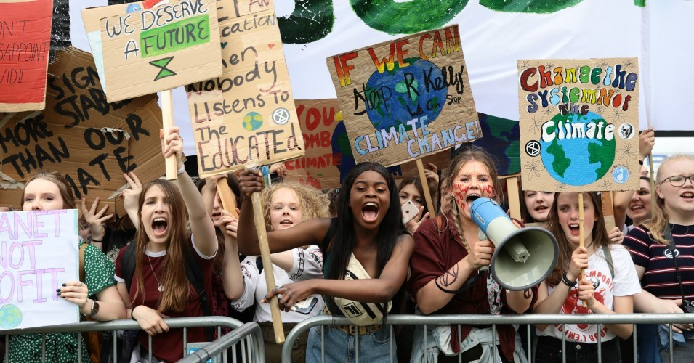

Students take part in a climate rally in Parliament Square on May 24, 2019 in London. (Photo: Dan Kitwood/Getty Images)

Please Read the Following Pieces before our First Meeting and Post your Thoughts on GauchoSpace before class!
John Foran, “Cracks in the Concrete: Toward a Hope that Works” (June 2018)
Daniel Lerch, “Responding to Collapse: Uncertain Future Forum’s First Week” (July 19, 2019)
James K. Rowe, “Zen and the art of social movement maintenance” (March 27, 2015)
Monday, August 5: Welcome, introduction, first discussions
After an introduction to the course and to each other we will start a discussion of the world situation today, and begin to identify some of the questions we may want to ask this quarter through a look at the nature of the intersecting crises humanity faces.
Readings: See above for three readings to do before class!
An optional video on the deep background to the crisis that you can watch any time you like is Capitalism Is The Crisis: Radical Politics in the Age of Austerity (directed by Michael Truscello, 2011, 99 minutes), a radical documentary that examines the roots of the Great Recession of 2008-9 and shows a variety of paths out of the current crisis, including that of the global justice movement, http://topdocumentaryfilms.com/capitalism-is-the-crisis/
Tuesday, August 6: How we feel about living in the shadow of catastrophe (and confronting the crisis with our collective class work!)
Today we will explore some of our feelings about living at this crucial moment in history, and discuss the class project options together.
Reading
Please try to read the first ten pages of the course syllabus so you can understand the big picture of this course better!
This Civilization is Finished, the following chapters: 1: “Gazing into the abyss;”, 2: “Climate chaos: black swan or white swan?” 13: “Crisis as opportunity;” and 17: “The beginning is near.”
Please check out the following as well – you will choose one of them for your class project!
Stream 1: Turning Isla Vista into Eco Vista: working on the Eco Vista Transition Initiative or Eco Vista and the Global Ecovillage Network
Eco Vista –
https://ecovistacommunity.com/
Transition United States –
http://www.transitionus.org/about-us
Global Ecovillage Network –
http://gen.ecovillage.org/en/article/what-ecovillage
Stream 2: Participation and observation of a local Climate Justice movement, such as the local Extinction Rebellion start-up and October week of action, the Sunrise Movement and the September School Strike for the Climate, or the Fossil Free UC organizing and the September Regents Meeting
Extinction Rebellion –
https://rebellion.earth/ and https://extinctionrebellion.us/
Sunrise Movement –
https://www.sunrisemovement.org/ and https://www.facebook.com/sunrisemvmntsb/
Fridays for Future – https://www.youthclimatestrikeus.org/
Fossil Free UC website – https://fossilfreeuc.net/
Fossil Free UC on Facebook – https://www.facebook.com/FossilFreeUC/
Stream 3: A Green New Deal strategy for Isla Vista or your home town
Sunrise GND: https://www.sunrisemovement.org/gnd and https://www.congress.gov/116/bills/hres109/BILLS-116hres109ih.pdf

Week Two: Crisis can also mean Opportunity
“There is no more potent weapon in the battle against fossil fuels than the creation of real alternatives.”
Naomi Klein, This Changes Everything: Capitalism vs. the Climate
*

Monday, August 12: Demain
Today we will screen and discuss the French film Demain/Tomorrow (Elle Driver, 2016, 96 minutes).
Reading
Have a look at the movie’s website, which is rich in content, solutions, and ideas for this class: https://www.demain-lefilm.com/en/film
Rob Hopkins, “The unstoppable rise of ‘Demain” (February 5, 2016), http://www.resilience.org/stories/2016-02-05/the-unstoppable-rise-of-demain
Tuesday, August 13: Our Tomorrow: A Class Brainstorm
Today we will discuss where we have arrived at the end of our first two weeks and to talk about our class projects. We will also begin to wrap our heads around the notion that there are systemic alternatives ready to be studied and perhaps even applied in our lives…
Reading
Pablo Solón, “What are Systemic Alternatives?” (April 11, 2019), https://www.resilience.org/stories/2019-04-11/what-are-systemic-alternatives/

Week Three: Systemic Alternatives
There is no doubt that after decades of what has been called ‘development’, the world is in crisis – systemic, multiple, and asymmetrical; long in the making, it now extends across all continents. Never before did so many crucial aspects of life fail simultaneously, and people’s expectations for their own and children’s futures look so uncertain. Crisis manifestations are
felt across all domains: environmental, economic, social, political, ethical, cultural, spiritual, and embodied….

What has been missing is a broad transcultural compilation of concrete concepts, worldviews, and practices from around the world, challenging the modernist ontology of universalism in favour of a multiplicity of possible worlds. This is what it means to call for a Pluriverse…
From the introduction to Pluriverse
*
Monday, August 19 and Tuesday, August 20: Meet the Pluriverse
This week’s meetings will be a plunge into to the amazing array of alternative ideas, practices, and experiments from all over the world. Our text is the new book, Pluriverse. We will work out how to accomplish this feat together…
Reading
Alberto Acosta, Federico Demaria, Arturo Escobar, Ashish Kothari, Ariel Salleh, Pluriverse: A Post-Development Dictionary (New Delhi: Tulika Books, 2019), selected chapters.

Week Four: Future Scenarios
We do not know how long we have, but we do know that the fight just can’t wait. And we know that just fighting isn’t enough: to succeed, we must simultaneously work for immediate changes and advance a vision of the world we want to build.
Ian Angus, Facing the Anthropocene: Fossil Capitalism and the Crisis of the Earth System
*
Monday, August 26: Jonathon Porritt: The World We Made
This week’s meetings will be whirlwind tour through two visionary looks into the future. And as we did last week, we will work out how to accomplish this together…
Reading
Jonathan Porritt, The World We Made: Alex McKay’s Story from 2050 (London: Phaidon Press, 2013), selected chapters
Jonathon Porritt on The World We Made, https://www.phaidon.com/agenda/architecture/articles/2013/october/02/jonathon-porritt-on-the-world-we-made/
Tuesday, August 27: Paul Raskin, Journey to Earthland
Reading
Paul Raskin, Journey to Earthland: The Great Transition to Planetary Civilization (Boston: Tellus Institute, 2016), selections
Feel free to skim some of the 100-plus page “Comments” on this book posted as a single document on GauchoSpace.

Week Five: Transformative, Visionary Change and Us
We need to engage in whatever actions appeal to us. There is no act too small, no act too bold. The history of social change is the history of millions of actions, small and large, coming together at certain points in history and creating a power which governments cannot suppress.
Howard Zinn, “An Occupied Country” (2002)
*
NO CLASS Monday, September 2: A Labor Day to Work on Our Projects!
Tuesday, September 3: The Politics of the Future: How Do We Get What We Want: Class Brainstorm
Today we will have an open discussion of how to realize our visions of a better future. Instead of a “Reading Response” for this week, post your thoughts on this theme on GauchoSpace before class. To prepare, you could review the course materials, think about your projects, and consciously activate your imaginations…
Reading
Read each others’ “Thought Responses” and replies on GauchoSpace before class.
Umair Haque, “‘The Story’: Life, the World, Now, You, and Me” (September 14, 2017), https://eand.co/the-story-eea04d97062b

Week Six: The Future will be Made by Us
“In order to carry a positive action we must develop here a positive vision.”
Dalai Lama
*
Monday, September 9: Presentations and Coming to Closure…
Today we will present our class projects to each other.
Tuesday, September 10: Presentations and Celebration
Today we will conclude our work in a variety of ways and there will be surprises! This will also be a final brainstorming session about everything we’ve all learned and for those who are interested, some discussion of how we might get more involved in hands-on fixing the world for the better.
Final projects are due on Saturday, September 14 by midnight.
*
Abolish grades.
Abolish email.
Abolish borders.
Abolish prisons.
Create love, beauty, and justice instead.
The beginnings of my platform.
(And the government is run by cats, natural anarchists.)
- Molly Talcott

If you have a learning or physical disability and require extended time to complete assignments, please contact John Foran and Ken Hiltner in the first week of the course.

